*You are receiving this email as a member of the media.*

*If you wish to unsubscribe from future messages, please reply with UNSUBSCRIBE in the subject line.*

**NEWS RELEASE**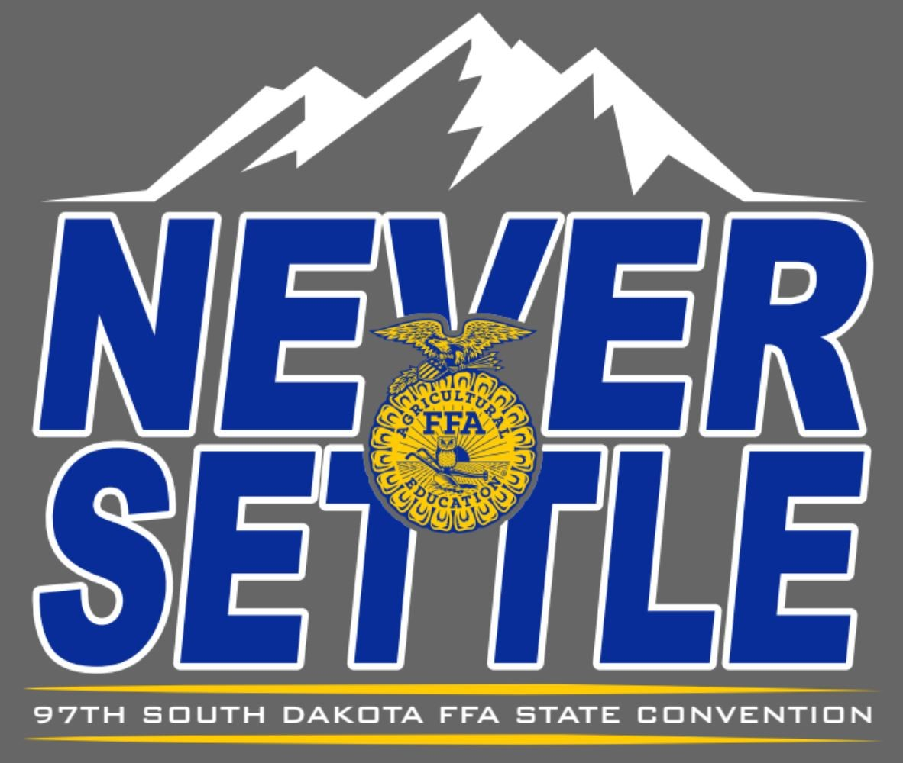

**South Dakota FFA Association**

|  |
| --- |
| Website: [www.sdaged.org](http://www.sdaged.org/) |
| Facebook: [www.facebook.com/South.Dakota.FFA](http://www.facebook.com/South.Dakota.FFA) |
| Instagram: @sdffaassociation |
|  |
| **For more information, contact:** |
| Caroline Hansen |
| South Dakota Leadership and Program Manager |
| Caroline.hansen@sdaged.org |

**FOR IMMEDIATE RELEASE**

April 8, 2025

**Photos of top 3 individuals in each area are available to download at:** [**https://drive.google.com/drive/folders/1_04VSp9-1PP77VYzXL79cKT7qn3wyORv**](https://drive.google.com/drive/folders/1_04VSp9-1PP77VYzXL79cKT7qn3wyORv)

**South Dakota FFA Proficiency Winners Recognized**

BROOKINGS, S.D. – South Dakota FFA members were recognized at the 97th South Dakota State FFA Convention for excellence in developing career-specific skills through their Supervised Agricultural Experience (SAE) Proficiency projects.

The FFA Agricultural Proficiency Awards recognize members who have developed their skills and abilities related to employment, internships, apprenticeships and their future careers at agribusiness or agriculture-related organizations. There are over 40 Proficiency areas for FFA members to participate in. The results are as follows:

**Agricultural Communications is** sponsored by the Tri-State Neighbor.

1. Hayden Hofer, Bridgewater-Emery
2. Cash Lehman, Bridgewater-Emery
3. Mallory Gant, Platte-Geddes

**Agricultural Education i**s sponsored by Dr. Lon and Mary Moeller (Dr. Lon Moeller pictured).

1. Lacie Weber, Howard
2. Elena Andrews, Beresford
3. Bobbi Eide, Gettysburg

**Agricultural Mechanics Design & Fabrication** is sponsored by Cammack Ranch Supply.

1. Keagan Kettwig, Parker
2. Gabriel Stern, Brookings
3. Holden Wollmann, Bridgewater-Emery

**Agricultural Mechanics Repair and Maintenance (Entrepreneurship)** is sponsored by Titan Machinery, C&B Equipment, Grossenburg Implement and Sitework Specialist.

* + - 1. Mason Jacobson, Howard
      2. Reece Gerlach, West Central
      3. Brady Braaten, Tri-Valley

**Agricultural Processing** is sponsored by the SD Soybean Processors LLC and SDSU Dairy and Food Science Department (Londa VanderWal Nwadike pictured).

1. Austin Severson, Howard
2. Abbie Chase, McCook Central
3. Dylan Wollman, Bridgewater-Emery

**Agricultural Sales** **(Entrepreneurship)** is sponsored by Legend Seeds, Inc.

1. Ava Sieverding, McCook Central

**Agricultural Sales (Placement)** is sponsored by M&M Cattle Services and SD Aviation Association.

1. Isabella Jimenez, McCook Central
2. Ethan Koopman, Tri-Valley
3. Noah Severson, Howard

**Agricultural Services** is sponsored by On Target Agency and Loehr Horse Care.

1. Josie Johnson, Buffalo Christian
2. Mikalyn Kelly, Brookings
3. James Kahnke, Florence

**Agriscience Research - Animal Systems** is sponsored by the CHS Foundation (Jen Johnson pictured).

1. Colton Stiefvater, McCook Central
2. Atlee Olson, Belle Fourche
3. Kelsey Vockrodt, West Central

**Agriscience Research** **- Integrated Systems** is sponsored by Terry Jaspers and Valley Queen Cheese.

1. Paul Kaffar, McCook Central
2. Zoe Dissing, Tri-Valley
3. Addison Ecklein, McCook Central

**Agriscience Research** **- Plant Systems** is sponsored by SoDak Labs, Inc. ( Christy Sternhagen pictured).

1. Alexa Pulse, McCook Central

**Beef Production (Entrepreneurship)** is sponsored by Stewart Charolais, Vedvei Charolais, Renovo Seed, and SD Shorthorn Association.

1. Ireland McAreavey, Tri-Valley
2. Cash Lehrman, Bridgewater-Emery
3. Caden Phelps, Arlington

**Beef Production (Placement)** is sponsored by the South Dakota Cattlemen's Association and the Blair Brothers.

1. Ryan Blagg, McCook Central
2. Karlie Stiefvater, McCook Central
3. Dylan McGregor, McCook Central

**Dairy Production (Entrepreneurship)** is sponsored by Associated Milk Producers, Inc (Brian Saarie pictured).

1. Skyler Plucker Lennox-Sundstrom
2. Brityn Davies, Lake Preston
3. Lauren Klitzke, McCook Central

**Dairy Production** **(Placement)** is sponsored by Associated Milk Producers, Inc. (Brian Saarie pictured)

1. Blaze Klitzke, McCook Central
2. Paige Haase, Parker
3. Aiden Healy, West Central

**Diversified Agricultural Production** is sponsored by Sioux Nation Ag, Kevin and Amber Blagg, and Blane and Liz Osterday.

1. Cash Lehman, Bridgewater Emery
2. Elana Andrews, Beresford
3. Karlie Stiefvater, McCook Central

**Diversified Crop Production (Entrepreneurship)** is sponsored by Agtegra Cooperative.

1. Ridge Roduner, Wessington Springs
2. Jason Zeeb, Bridgewater-Emery
3. Thomas Halverson, Howard

**Diversified Horticulture** is sponsored by the South Dakota Soil Health Coalition (Cindy Zenk pictured).

1. Kaylee Klinkhammer, McCook Central
2. Kenasyn Johnson, West Central

**Diversified Livestock Production** is sponsored by McFleeg Inc.

1. Kylie Mockler, Beresford
2. Caden Phelps, Arlington
3. Delaney Zoss, Mitchell

**Environmental Science & Natural Resources Management** is sponsored by South Dakota Association of Conservation Districts (Matt Eichacker pictured) and Site Work Specialists, Inc.

2. Luke Horstman, McCook Central

**Equine Science (Entrepreneurship)** is sponsored by Amani Reiners – Tim Anderson and Kim Niven of Milbank.

1. Taten Twedt, Beresford
2. Josie Nold, Brookings
3. Elle Goehring, Parkston

**Equine Science (Placement)** is sponsored by Scott Cammack, Dawn Nagel (pictured), Susan Stoterau (pictured), and Webster FFA.

* + - 1. Shayda Ness, Kimball
      2. Taya Wettlaufer, Howard
      3. Cash Martinez, Bridgewater-Emery

**Fiber and/or Oil Crop Production** is sponsored by SD Soybean Research and Promotion Council (Jerry Schmitz pictured).

1. Briella Wettlaufer, Howard
2. Karlie Stiefvater, McCook Central
3. Ridge Roduner, Wessington Springs

**Forage Production** is sponsored by Kuecker Seed Farm, Inc. of Webster (Amy Kuecker pictured).

1. Jason Zeeb, Bridgewater-Emery
2. Karlie Stiefvater, McCook Central

**Forest Management and Products** is sponsored by the SD FFA Foundation.

1. Lawden Haak, Howard
2. Daraby Boresma, SBA

**Fruit Production** is sponsored by myfruitsale.com (Lynn Stoneking pictured).

* + - 1. Isabella Smithback, Harrisburg
      2. Luke Larson, Wessington Springs
      3. Renee Uberty, McCook Central

**Goat Production** is sponsored by Hamilton Farms of Hitchcock.

**Sponsor in photo:** Nicole Roth

1. Carley Crist, Beresford
2. Cash Martinez, Bridgewater-Emery
3. Ryan Blagg, McCook Central

**Grain Production** is sponsored by Dakota Mill and Grain Inc. and the South Dakota Wheat Commission.

1. Karlie Stiefvater, McCook Central
2. Jason Zeeb, Bridgewater-Emery
3. Lauren Roling, McCook Central

**Home and Community Development** is sponsored by the Beal Family.

1. Katrina Thon, Bridgewater-Emery
2. Vivian Keospell, McCook Central
3. Breana Zapp, McCook Central

**Landscape Management** is sponsored by FarmHouse Fraternity-SDSU.

1. Avery Alley, McCook Central
2. Nolan Mentele, Howard
3. Daraby Boresma, SBA

**Nursery Operations** is sponsored by Twin Cities Region Northland Ford Dealers.

1. Macie Weber, Bridgewater-Emery

**Outdoor Recreation** is sponsored by Jack’s Campers of Mitchell, Central Dakota Guide Service and South Dakota Walleye Charters.

1. Connor May, Brookings
2. Lacie Weber, Howard
3. Robert Hine, Wessington Springs

**Poultry Production** is sponsored by Josh Johnson (pictured) and the South Dakota Poultry Industries Association.

1. Rachel Brown, Bridgewater-Emery
2. Josie Nold, Brookings
3. Katrina Thon, Bridgewater-Emery

**Service Learning** is sponsored by Dr. Laura Hasselquist and Toby Uecker.

**Sponsor:** Toby Uecker and Dr. Laura Hasselquist

1. Lauren Roling, McCook Central
2. Katrina Thon, Bridgewater-Emery

**Sheep Production** is sponsored by the Newell Ram Sale and Rufus & Patty DeZeeuw.

1. Josie Nold, Brookings
2. Melanie Calmus, Howard
3. Carissa Scheel, Wessington Springs

**Small Animal Production and Care** is sponsored by Salem Veterinary Service (Mike Stiefvater pictured), SD Veterinary Medical Association, and Robert & Sandy Rennolet.

1. Alyssa Roling, McCook Central
2. Katrina Thon, Bridgewater-Emery
3. Taylor Hawley, Brandon Valley

**Specialty Animal Production** is sponsored by Wendy Mortenson Agency.

1. Abbie Chase, McCook Central
2. Joseph Kayser, Bridgewater-Emery

**Swine Production** **(Entrepreneurship)** is sponsored by the South Dakota Pork Producers Council (Abbey Riemenschneider pictured).

1. Dawson Plagmann, Bridgewater-Emery
2. Addison Fedeler, Howard
3. Caden Phelps, Arlington

**Swine Production (Placement)** is sponsored by GroMaster (Marvin Wastell pictured), Kevin and Sandy Ortberg, Wally & Kathy Knock.

1. Elena Andrews, Beresford
2. Melanie Calmus, Howard
3. Chase Jones, Tri-Valley

**Turf Grass Management** is sponsored by Renovo Seed.

1. Gracie Pedersen, Tri-Valley
2. Karlee Klinkhammer, McCook Central
3. Isaac Boden, Beresford

**Vegetable Production** is sponsored by Clark and Lyla Hanson in memory of Bill and Stella Hanson.

1. Bobbi Eide, Gettysburg
2. Ava Couser, Brookings
3. Parker Burke, Bridgewater-Emery

**Veterinary Science** is sponsored by Salem Veterinary Service **(**Mike Stiefvater pictured).

1. Hope Baysinger, Mitchell
2. Karmen Iverson, Chester
3. Colton Stiefvater, McCook Central

**Wildlife Production and Management** is sponsored by Craig (pictured) and Maure Weinkauf.

1. Joseph Grady, McCook Central
2. Korbin Shumaker, Howard
3. Kennedy Nemitz, Brookings

**About the South Dakota FFA Association:** The National FFA Organization is a national youth organization of 850,823 student members as part of 8,995 local FFA chapters in all 50 states, Puerto Rico and the Virgin Islands. As part of the National FFA Organization, the South Dakota FFA Association encompasses 109 FFA chapters with over 5,000 South Dakota FFA members. FFA strives to make a positive difference in the lives of students by developing their potential for premier leadership, personal growth and career success through agricultural education. To discover more about the South Dakota FFA Association or the South Dakota FFA Foundation, visit them both at sdaged.org or on Facebook and Instagram.

- ### -